Inspiration 8

Writing and Drawing for Pleasure
It’s almost half term. In the school holidays I nearly always wrote a story or poem. I’ve kept some of them too. This story and doodle is from my own writing notebook many years ago! The wonderful illustrator Poonam Mistry who illustrated The River Whale has created this illustration inspired by my poem ‘Dolphins in the Darkness’.
Write your own poem inspired by water and if you would like you can illustrate it too. Have a look at Poonam’s website to see the incredible ways she depicts water in her art. (https://www.poonam-mistry.com/)
I never dreamed I would be an author… maybe your #WaterStory will lead you to become one too.

Dolphin Dream
The night has painted my window like the sea
Moonshine blue
Pale crested tendrils of pastel waves
reach for the ebb and flow of the deep
There are dolphins in the darkness….
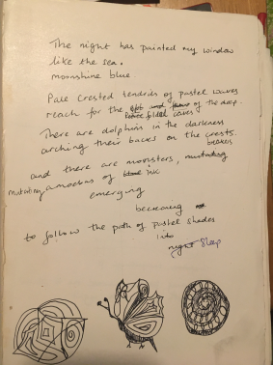
Excerpt of childhood poem ‘Dolphin Dream’ with editing by Sita Brahmachari and illustration by Poomam Mistry.
