Inspiration 4

Water story myths and legends
Here is an image from ‘Corey’s Rock’ illustrated by Jane Ray. Research what a Selkie story is. Why do you think people from all around the world tell Selkie stories? Why does the sea capture our imaginations so fully?
Write your own myth that connects human and sea creatures together. Here Isla find a seal skin to weave her story together, but you can choose any sea creature large or small. In ‘The River Whale Imtiaz meets a whale and sea-horses! All magical creatures. Don’t be afraid to make up words.
Somewhere in your story use this line.
‘Listen to the call within’
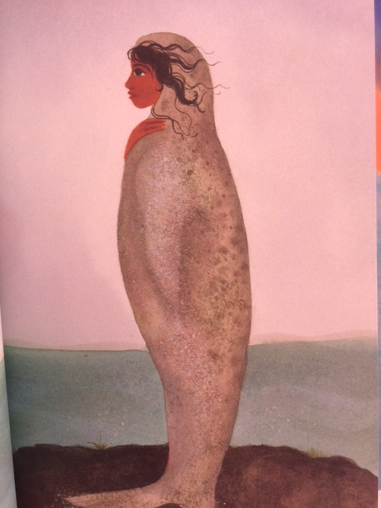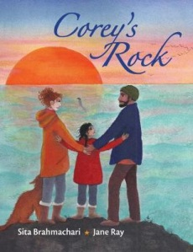

Re-wild your imagination and dive into mythology.

