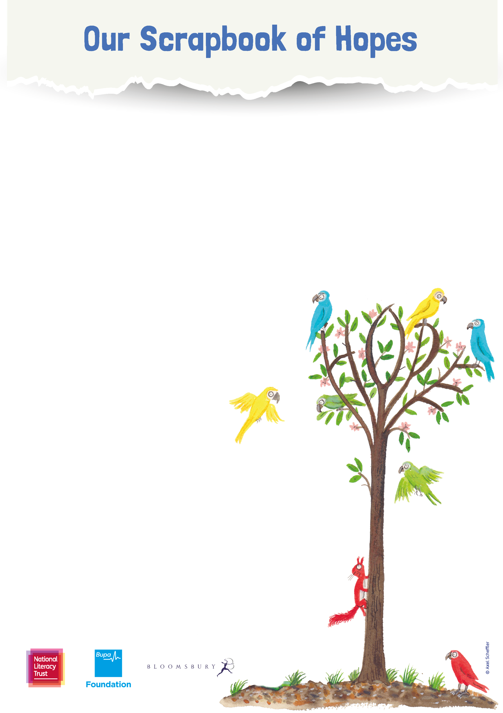

**School name:**

**School address:**

**Town/city:**

**County:**

**Postcode:**

**­**

**Teacher name:**

**Contact email:**

**Class/Year group:**



**Tell us what you’ve been up to:**

**This Scrapbook of Hopes is designed to gather together the ideas, activities, drawing, writing, reading, and talking you have been sharing across your school and wider community this term to spread hope, kindness and a love of reading.**

**Using the space below, add your description of your activities (up to a maximum of 250 words) in paragraphs, bullet points or with picture captions. You can add pictures in this scrapbook, or attach up to three separate picture files when you email your scrapbook to us.**

**Be sure to add your contact details and school name on the front of your scrapbook, and email it to** [**bookofhopes@literacytrust.org.uk**](mailto:bookofhopes@literacytrust.org.uk) **by 31 January 2021 for your chance to win prizes including beautiful signed artwork and books for your school plus a virtual author visit from Katherine Rundell.**

**Visit** [**literacytrust.org.uk/scrapbook-of-hopes**](http://www.literacytrust.org.uk/scrapbook-of-hopes) **for full details. Terms and conditions apply.**

Our school:



**Tell us what you’ve been up to:**