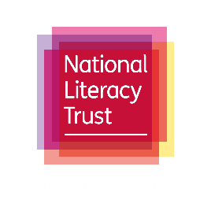
Words of daughters
Irish father
Uncovers a home in Haworth,
Gem stones buried in eyes
How worthy are we of words from daughters

These moors are mountains
That harbour them,
as the world hardens their skin, with grief, loss
empathy in their touch isn't empty,

Church bells ring in their chest,
Speak, write, your words are equal to men
Recite your rituals around oak table
Circle and spin with love like the earth
Laugh a belly full of joy
Reformer in the form of Jane
It’s a shame this withering height of men
It's about time they fell.

Never lower your dreams like the ceilings of father’s timid house. Rush you are the wind keep pushing, don’t let the upward slope slow you down, pressure is the same as the heat in kitchen or the harsh fists in schools

A pilgrimage to parsonage, as father studies, showing you how spine arch in quills, scratch your message in ink, as the weather has no colour here. You are your father glasses, a vision he couldn't see without

They Hear your struggle today, Brontë your words travel in books
As I pass the room you past in.
I circle just like you, through the grave yards and church rooms searching for siblings.

Your inspiration comes out of isolation,
as fingers play minor keys
in this house,
These walls heard and held daughters
Words, as well as their bodies,
these floors followed felt each step, a journal of a journey conveyed by bricks.
How worthy are we of daughters words, which will always return to this place where their words became alive
People roll in with the hills to this
home in Haworth which gave hope to our daughters.

Saju Iqbal Ahmed

