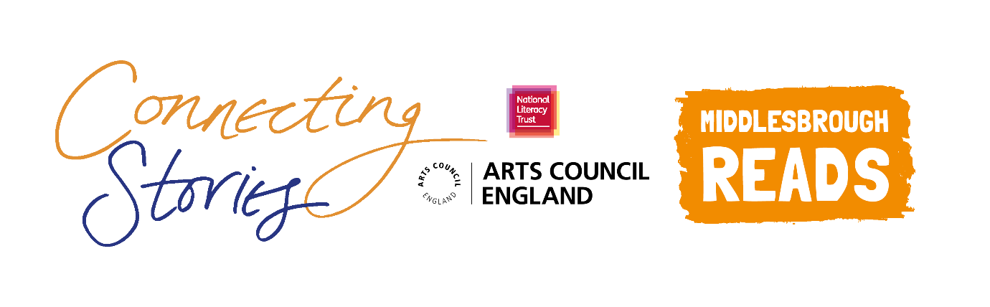

**Creative Writing Competition: ‘Middlesbrough and Me’**

**National Literacy Trust and** **Middlesbrough Reads** are delighted to launch an exciting creative writing competition as part of the Connecting Stories project, with support from the authors Matt Oldfield and Jamie Russell. We are inviting children aged 7-11 to create a piece of writing based on the theme ***‘Middlesbrough and Me’.***

This is a chance to share your experience of growing up in Middlesbrough. How has living in Middlesbrough shaped your life and who you are? What makes Middlesbrough special to you - the people, your school, the places you visit?

You can choose any format you like – a story, a poem, news article or diary entry. You can include some illustrations too.

Everyone who enters the competition will receive a certificate and will have a chance to get their work published in an anthology and displayed in a local exhibition. There will also be book prizes for the winning entries.

Winning entries will be chosen based on originality, imagination, relation to the theme and overall enjoyment.

**How to enter**

* Use the blank space in this booklet or a side of A4 paper to complete your piece of writing.
* Ask your parent/guardian or teacher to scan or photograph your work and enter online at [www.literacytrust.org.uk/communities/connecting-stories](http://www.literacytrust.org.uk/communities/connecting-stories) or email it to [middlesbroughcs@literacytrust.org.uk](mailto:middlesbroughcs@literacytrust.org.uk). Don’t forget to include your first name and first letter of your surname, your age and school.

**Privacy notice**

The National Literacy Trust will need to hold and process your personal data in order to manage this competition. We will only use it for this purpose we will never pass on personal information to any other organisations unless specific consent has been given. For our full privacy policy see literacytrust.org.uk/privacy



**‘Middlesbrough and Me’: Writing prompts**

Your piece of writing can be funny, heart-warming, adventurous or exciting, fiction or non-fiction, everything is welcome!

* Write about a place in Middlesbrough that is special to you. How does it make you feel, and why? Do you have any special memories about that place?
* Perhaps you could write a news article about life in Middlesbrough for young people at the moment? What would you like to tell the rest of the country about where you live?
* Can you tell us about a typical day in your life? Write about the people you spend time with, and the places you go. What activities do you most enjoy?

* You could imagine aliens have come to Middlesbrough – what would you tell them about Middlesbrough and your life here? Where would you take them?

**Describing Middlesbrough**

* Think about your favourite local places, shops, landmarks. Why do you like these places? Are they fun, exciting, unique?
* Think about the people that make Middlesbrough so wonderful. Why are they special? Are they funny, interesting, kind? What do they look and sound like? How do they inspire and help you?

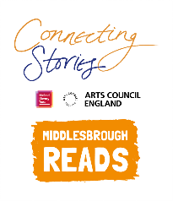

Name Click or tap here to enter text. Age Click or tap here to enter text.

School Click or tap here to enter text.

Parent/Guardian/Teacher email address Click or tap here to enter text.

Parent/Guardian: I give permission for this work, along with the name, age and school provided, to be published in an anthology and displayed online or in public venues.



**Competition Rules**

* The competition is open to children and young people aged 7-11, however entries from all primary school pupils will be considered for the exhibition.
* The closing date for submission is Friday 12th March 2021. Winners will be announced at the beginning of April.
* Entries should be one page of A4 or 500 words maximum and written in English.
* The piece of creative writing must be an original piece of work and be wholly written by the entrant. It must reflect the theme of the competition as stated in the competition challenge. The writing must be single-authored.
* Entries must not contain obscene, defamatory, offensive or otherwise unsuitable material. The organisers reserve the right to disqualify such entries.
* A team of community partners and National Literacy Trust staff will shortlist entries and winners will be chosen by our panel of experts.
* On submission, parents/guardians will be asked to grant permission to enter. They will be asked for consent to publish the entrant’s writing online or in print form, or display physical entries in public spaces.
* Teachers submitting on behalf of their pupils must obtain permission from parents/ guardians prior to submission. As a teacher, by entering your pupils’ work into this competition you are confirming that written parental consent has been sought and confirmed in advance of the submission. National Literacy Trust will not be held liable in the instance that consent has not been sought.