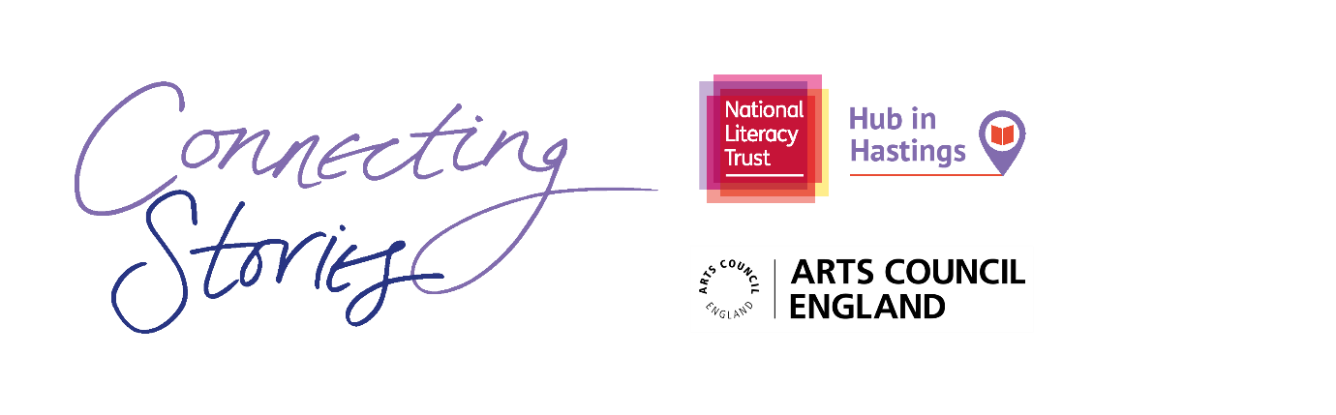

**Creative Writing Competition: ‘Discovery’**

**National Literacy Trust’s Hub in Hastings** are delighted to launch an exciting creative writing competition as part of the Connecting Stories project, with support from the fantastic children’s author Lesley Parr. We are inviting children aged 7-11 from across Hastings to create a piece of writing based on the theme ***‘Discovery’***

In Lesley Parr’s brilliant book *Valley of the Lost Secrets*, the main character Jimmy makes a startling discovery inside a hollow tree. Lesley wants you to imagine that your character finds something shocking or unusual in an ordinary place – something they would not expect to be there! What is it? Where is it? And, most importantly, what will your character do about it?

You can choose any format you like – a story, a poem, news article or diary entry. You can include some illustrations too.

Everyone who enters the competition will receive a certificate and will have a chance to get their work published in an anthology and displayed in a local exhibition. There will also be book prizes for the winning entries.

Winning entries will be chosen based on originality, imagination, relation to the theme and overall enjoyment.

**How to enter**

* Use the blank space in this booklet or a side of A4 paper to complete your piece of writing.
* Ask your parent/guardian or teacher to scan or photograph your work and enter online at [www.literacytrust.org.uk/communities/connecting-stories](http://www.literacytrust.org.uk/communities/connecting-stories) or email it to hastingscs@literacytrust.org.uk. Don’t forget to include your first name and first letter of your surname, your age and school.

**Privacy notice**

The National Literacy Trust will need to hold and process your personal data in order to manage this competition. We will only use it for this purpose we will never pass on personal information to any other organisations unless specific consent has been given. For our full privacy policy see literacytrust.org.uk/privacy



**‘Discovery’: Writing prompts**

You can write about a place you know, or one from your own imagination. In Lesley’s book, she did a mixture of both. But the essential thing is that the discovery has to really surprise your character!

Here are some ideas to inspire you if you’re feeling a bit stuck:

* Think about the places you know well. Where could you hide something that you wouldn’t want anyone else to find?
* What does this place look like? What can you hear and smell?
* What things might someone want to hide, and why? What kind of thing would you like to discover? What would scare or surprise you if you found them?
* Imagine how it would feel to find something you weren’t expecting. Think of some words you could use to describe your reactions.
* You could write a diary entry describing how you made the discovery. A newspaper article reporting on it. Anything you can imagine.
* What does the discovery mean for you and your family? What does it mean for the people of Hastings?

Your piece of writing can be funny, heart-warming, adventurous or exciting, fiction or non-fiction, everything is welcome!

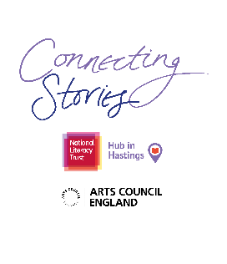First name and first letter of surname Click or tap here to enter text.

Age Click or tap here to enter text.

School Click or tap here to enter text.

Parent/Guardian/Teacher email address Click or tap here to enter text.

Parent/Guardian: I give permission for this work, along with the name, age and school provided, to be published in an anthology and displayed online or in public venues.



**Competition Guidance**

* The competition is open to children and young people aged 7-11, but entries from all primary school pupils will be considered for the exhibition.
* The closing date for submission is Friday 12th March 2021. Winners will be announced at the beginning of April.
* Entries should be one page of A4 or 500 words maximum and written in English.
* The piece of creative writing must be an original piece of work and be wholly written by the entrant. It must reflect the theme of the competition as stated in the competition challenge. The writing must be single-authored.
* Entries must not contain obscene, defamatory, offensive or otherwise unsuitable material. The organisers reserve the right to disqualify such entries.
* A team of community partners and National Literacy Trust staff will shortlist entries and winners will be chosen by our panel of experts.
* On submission, parents/guardians will be asked to grant permission to enter. They will be asked for consent to publish the entrant’s writing online or in print form, or display physical entries in public spaces.
* Teachers submitting on behalf of their pupils must obtain permission from parents/ guardians prior to submission. As a teacher, by entering your pupils’ work into this competition you are confirming that written parental consent has been sought and confirmed in advance of the submission. National Literacy Trust will not be held liable in the instance that consent has not been sought.