Half Term Inspiration
Dear fellow authors,
I hope that you are inspired to write a Water Story.
Maybe you are at the stage when you are ready to look over all the inspirations so far and choose something or a collection of things that you would like to write about. Whenever I set out to write a story I do what I call a collage collection of all the things I’ve read or thought about that stay in my mind. I do this from memory.
I close my research and ideas book and make a list of the things that have most inspired me about the subject.
Here is the list of ideas I wrote just before I set out to write ‘The River Whale.’
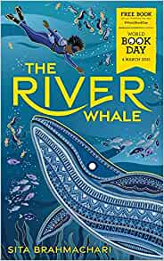
Imtiaz (In her voice)
Marine biology
Underwater tour of Thames (look online)
Plastic pollution
Mud larking
Love of whales
I want the words to glide/ wash/ float across the pages
When Imtiaz is underwater or dreaming.

Now make your own collage notes and let your ideas flow.
We Water Stories judges are so excited to read your Water Stories. There are some fantastic prizes to win and I look forward to visiting the school with the winning entry.

Sita Brahmachari

