THE WATER BABIES Source: http://www.gutenberg.org/files/1018/1018-h/1018-h.htm
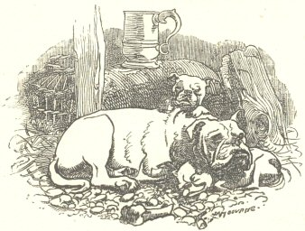
Once upon a time there was a little chimney-sweep, and his name was Tom. That is a short name, and you have heard it before, so you will not have much trouble in remembering it. He lived in a great town in the North country, where there were plenty of chimneys to sweep, and plenty of money for Tom to earn and his master to spend. He could not read nor write, and did not care to do either; and he never washed himself, for there was no water up the court where he lived. He had never been taught to say his prayers. He never had heard of God, or of Christ, except in words which you never have heard, and which it would have been well if he had never heard. He cried half his time, and laughed the other half. He cried when he had to climb the dark flues, rubbing his poor knees and elbows raw; and when the soot got into his eyes, which it did every day in the week; and when his master beat him, which he did every day in the week; and when he had not enough to eat, which happened every day in the week likewise. And he laughed the other half of the day, when he was tossing halfpennies with the other boys, or playing leap-frog over the posts, or bowling stones at the horses’ legs as they trotted by, which last was excellent fun, when there was a wall at hand behind which to hide. As for chimney-sweeping, and being hungry, and being beaten, he took all that for the way of the world, like the rain and snow and thunder, and stood manfully with his back to it till it was over, as his old donkey did to a hail-storm; and then shook his ears and was as jolly as ever; and thought of the fine times coming, when he would be a man, and a master sweep, and sit in the public-house with a quart of beer and a long pipe, and play cards for silver money, and wear velveteens and ankle-jacks, and keep a white bull-dog with one gray ear, and carry her puppies in his pocket, just like a man. And he would have apprentices, one, two, three, if he could. How he would bully them, and knock them about, just as his master did to him; and make them carry home the soot sacks, while he rode before them on his donkey, with a pipe in his mouth and a flower in his button-hole, like a king at the head of his army. Yes, there were good times coming; and, when his master let him have a pull at the leavings of his beer, Tom was the jolliest boy in the whole town.
The opening of ‘The Water Babies’ by Charles Kingsley (1863)
GLOSSARY:
Court - a quadrangular area surrounded by a building or group of buildings
Soot – the black powder produced when coal or wood burns
Flues - a pipe or long tube that acts as a chimney, taking smoke away from a device
Velveteens – trousers made of thick material
Ankle-jacks – ankle length boots
Leavings - things that have been left as worthless

