Finding examples of characterisation techniques

It’s always useful to carefully observe what successful authors do. Reading lots of stories will give you plenty of practice! Additionally, you can zoom in on specific techniques by using the CLiC web application. CLiC can help you research words and phrases that are frequently used to describe fictional characters and their body language.

Example: The eyes as the mirror to the soul

Below are examples of how Dickens uses the word eyes in Oliver Twist. What meanings does the description of the eyes help to convey in each of the three examples?

- Oliver, whose eyes had glistened at the mention of meat, and who was trembling with eagerness to devour it, replied in the negative; and a plateful of coarse broken victuals was set before him.

- 'Save us!' said the old lady, with tears in her eyes.

- 'Not I,' said Monks, turning away his eyes and beating his foot upon the ground, as a man who is determined to deny everything. 'Not I.'

As eyes are so meaningful, we also talk about ‘eye language’ as a special type of body language. To find more examples of eye language, you can look at a ‘concordance’, i.e. a list of all the occurrences of eyes in Oliver Twist, as in this sample here:

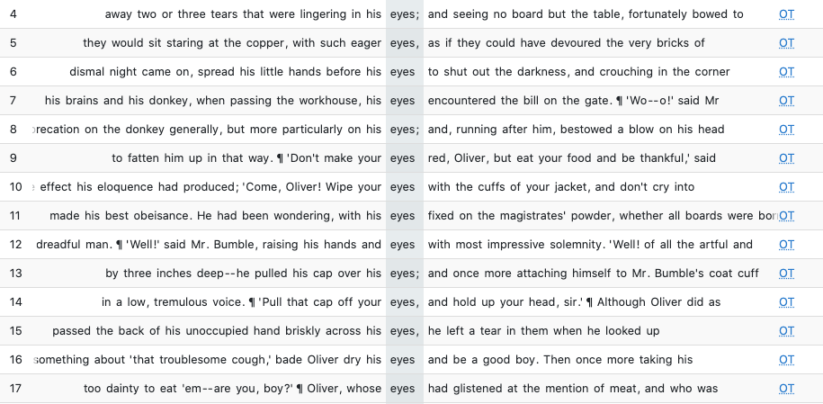

To retrieve a full list follow these easy steps.

Exercise: Retrieving examples of eyes in Oliver Twist

- Open the CLiC website in the Chrome browser (clic.bham.ac.uk)
- Click on the “Concordance tab” (1.)
- Under “Search the corpora” (2.), select “Oliver Twist”.
- Under “Search for terms”, enter “eyes” (3.). When you hit return you will see the examples of eyes appear in the concordance view.

1.
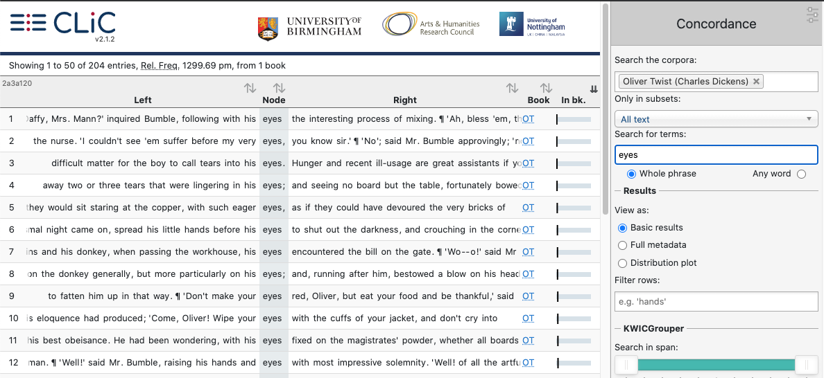
2.
4.
3.

- To get from a concordance line to a full text extract, click on the slider to see the “in bk.” (“in book”) view (4.). Your search word will be highlighted in yellow.

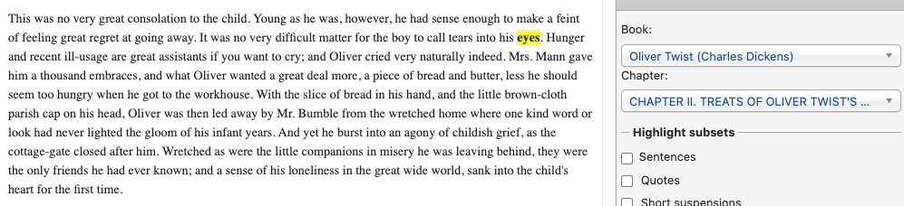

A concordance displays all occurrences of a word in a text (or set of texts).
It enables you to explore words in context and across the development of a text.

Other resources you might want to check out
- Our CLiC Activity Book: www.birmingham.ac.uk/clic-activity-book
- A short video on CLiC: https://www.youtube.com/watch?v=fnP2fkuocAA

You can use and adapt this handout for your own classroom activities as it is available freely under the following license:
This work is licensed under a Creative Commons Attribution-NonCommercial-ShareAlike 4.0 International License.
© 2020, Michaela Mahlberg & Viola Wiegand

