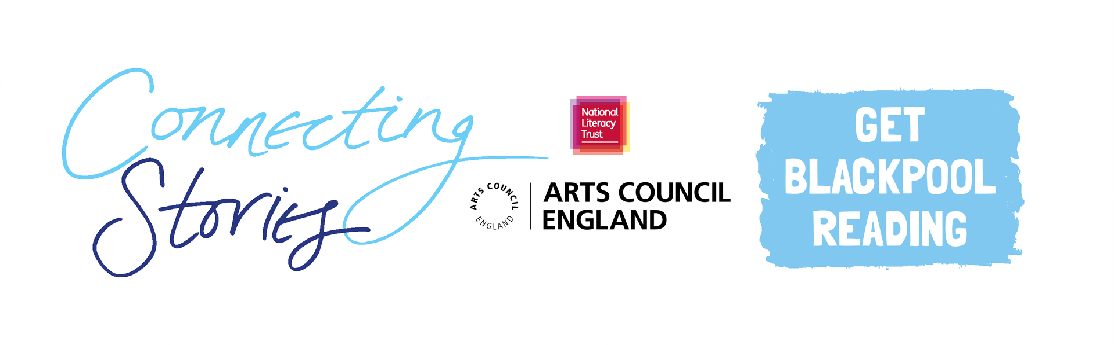

**Creative Writing Competition: ‘A Brighter Blackpool’**

**National Literacy Trust** and **Get Blackpool Reading** are delighted to launch an exciting creative writing competition as part of the Connecting Stories project. We are inviting young people aged 11-14 from Blackpool to create a piece of writing based on the theme ***‘A Brighter Blackpool’.***

The year is 2050 and we’d like to hear about the town you want Blackpool to be!

You can choose any format you like – a story, a poem, news article, comic or diary entry. You can include some illustrations too.

Everyone who enters the competition will receive a certificate and will have a chance to get their work published in an anthology and displayed in a local exhibition. There will also be book prizes for the winning entries.

Winning entries will be chosen based on originality, imagination, relation to the theme and overall enjoyment.

**How to enter**

* Use the blank space in this booklet or a side of A4 paper to complete your piece of writing.
* Ask your parent/guardian or teacher to scan or photograph your work and enter online at <https://literacytrust.org.uk/communities/blackpool/connecting-stories-blackpool/> or email it to [blackpoolcs.secondary@literacytrust.org.uk](mailto:blackpoolcs.secondary@literacytrust.org.uk). Don’t forget to include your first name and first letter your surname, your age and school.

**Privacy notice**

The National Literacy Trust will need to hold and process your personal data in order to manage this competition. We will only use it for this purpose we will never pass on personal information to any other organisations unless specific consent has been given. For our full privacy policy see [literacytrust.org.uk/privacy](https://literacytrust.org.uk/information/privacy-policy/).



**‘A Brighter Blackpool’: Writing prompts**

Your piece of writing can be funny, heart-warming, adventurous or exciting, fiction or non-fiction, everything is welcome!

Here are some ideas to get you started.

* How would you build your dream town in 2050? What kind of places, buildings and spaces would you like to visit?
* Will the town look very different and who will live here?
* Will you design any special technology for the town?
* What problems are no longer an issue?
* How has the town changed for the better?

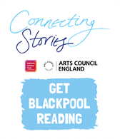First name and the first letter of your surname: Click here to enter text.

Age: Click or tap here to enter text. School: Click or tap here to enter text.

Parent/Guardian/Teacher email address: Click or tap here to enter text.

Parent/Guardian: I give permission for this work, along with the name and school provided, to be published in an anthology and displayed online or in public venues.



**Competition Guidance**

* The competition is open to young people aged 11-14, but entries from all year groups in high school will be considered for the exhibition.
* The closing date for submission is Friday 12th March 2021. Winners will be announced at the beginning of April.
* Entries should be one page of A4 or 500 words maximum and written in English.
* The piece of creative writing must be an original piece of work and be wholly written by the entrant. It must reflect the theme of the competition as stated in the competition challenge. The writing must be single-authored.
* Entries must not contain obscene, defamatory, offensive or otherwise unsuitable material. The organisers reserve the right to disqualify such entries.
* A team of community partners and National Literacy Trust staff will shortlist entries and winners will be chosen by our panel of experts.
* On submission, parents/guardians will be asked to grant permission to enter. They will be asked for consent to publish the entrant’s writing online or in print form, or display physical entries in public spaces.
* Teachers submitting on behalf of their pupils must obtain permission from parents/ guardians prior to submission. As a teacher, by entering your pupils’ work into this competition you are confirming that written parental consent has been sought and confirmed in advance of the submission. National Literacy Trust will not be held liable in the instance that consent has not been sought.
* National Literacy Trust will only use the information provided for the purposes for which it was obtained and that we will never pass on personal information to any other organisations unless specific consent has been given.