Podcasts
Here are six motivational podcasts to help kick start your career.

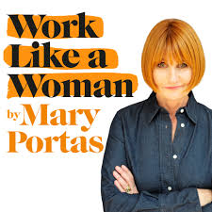
Work Like a Woman by Mary Portas
This podcast explores how we can put kindness and compassion at the heart of business. Joined by guests including Bryony Gordon and Greggs CEO, Roger Whiteside. Portas explains how we all have the power to change the world of work.
maryportas.com/podcast

Girlboss Radio with Sophie Amoruso
Each week Girlboss CEO Sophie Amoruso sits down for a conversation with an inspirational woman, who shares their tips for building a successful career or building their own business. With interviews featuring Jameela Jamil and Emily Weiss, to name a few.
play.acast.com/s/girlbossradio

Goal Digger
Social media influencer Jenna Kutcher shares her stories, tips and tricks on how to transform your passion into a profitable business. This podcasts focuses on productivity and career development.
podcast.jennakutcher.com

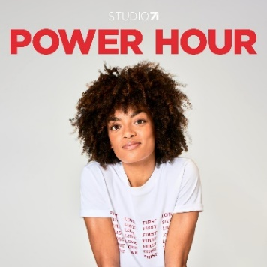
Power Hour
Adrienne Herbert’s Power Hour is a motivational podcast to help you make the most of your time and how to find success. The podcasts includes interviews with industry experts and change makers.
play.acast.com/s/powerhour

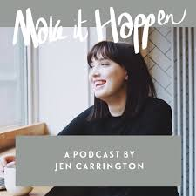
Make it Happen
Creative coach Jen Carrington provides amazing advice that will leave you feeling inspired and ready to kick start your career. Each podcast is bite sized at around 5-10 minutes long and filled with top tips that will help you to build a successful career.
makeithappenpodcast.com

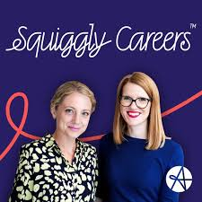
Squiggly Careers
Hosts Sarah Ellis and Helen Tupper tackle the question “Want to have a happy career and love your job but not sure where to start?” Featuring top tips on how to kick start your dream job alongside interviews from inspirational leaders.
play.acast.com/s/amazingif

